**PHYSICS YEAR 12 – MOTION TOPIC TEST 1**

Name: ________________________________ Weight: 5%

Materials: *Pens/Pencils, Eraser, Ruler, Calculator, Formula Sheet.*

Time: 55 Minutes.

*Give all numerical answers to 3 significant figures (estimation questions to 2 significant figures), unless instructed otherwise in the question.*

1. A 70 kg cyclist (inc. bicycle) rides their bicycle North along a flat, level stretch of road at a constant velocity of 4.50 m s-1, doing work against a 60.0 N friction force.
   1. What is the net force acting upon the cyclist? Justify your response:

(2 Marks)

* 1. The cyclist turns to the East with a new constant velocity of 3.50 m s-1. Find the change in velocity:

(4 Marks)

1. 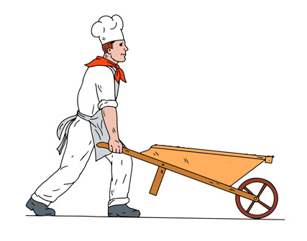A 20.0 kg wheelbarrow is being pushed at a constant velocity (by a chef… for reasons) such that the angle that the handle makes with the ground is 25˚. A horizontal friction force of 50.0 N opposes the motion of the wheelbarrow.
   1. Find the force applied by the chef on the wheelbarrow.

(2 Marks)

* 1. Find the force applied by the wheelbarrow on the chef.

(1 Mark)

1. Removalists need to load a 136 kg piano into a truck by placing it on a wheeled trolley and roll it up a ramp inclined at an angle of 22°. Ignore friction.

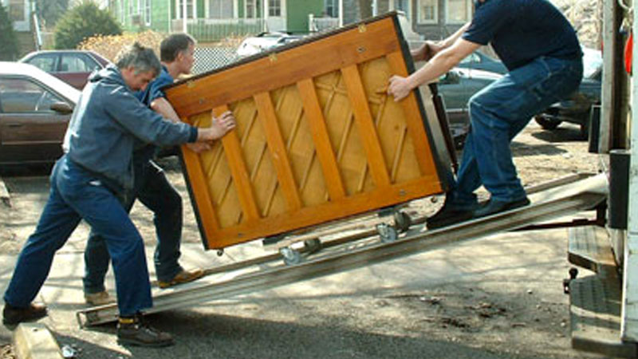

* 1. The ramp will bend significantly if the normal reaction exerted by the ramp exceeds 1250 N. Using calculations determine whether the ramp will bend significantly (ignore the weight of the removalists). Include a diagram in your answer.

(4 Marks)

* 1. Calculate the minimum force up the ramp that must be exerted by the removalists to load the piano into the truck.

(2 Marks)

1. A projectile is launched from a flat piece of land with a speed of 10.0 m s-1.
   1. Find the range if the projectile is launched at 30˚ to the horizontal:

(3 Marks)

* 1. What angle, other than 30˚, would achieve the same range for the projectile (assuming the same initial speed)? Justify your response:

(2 Marks)

1. Consider the motion-capture image below, taken from the 2018 PyeongChang Winter Olympics ski-jumping event in South Korea. Consider the first position of the ski-jumper to have been taken at time t = 0 seconds, and the angle of the jump to be approximately 70˚ to the horizontal. The maximum height achieved by the ski-jumper (above the first position) measures at 5.62 m.

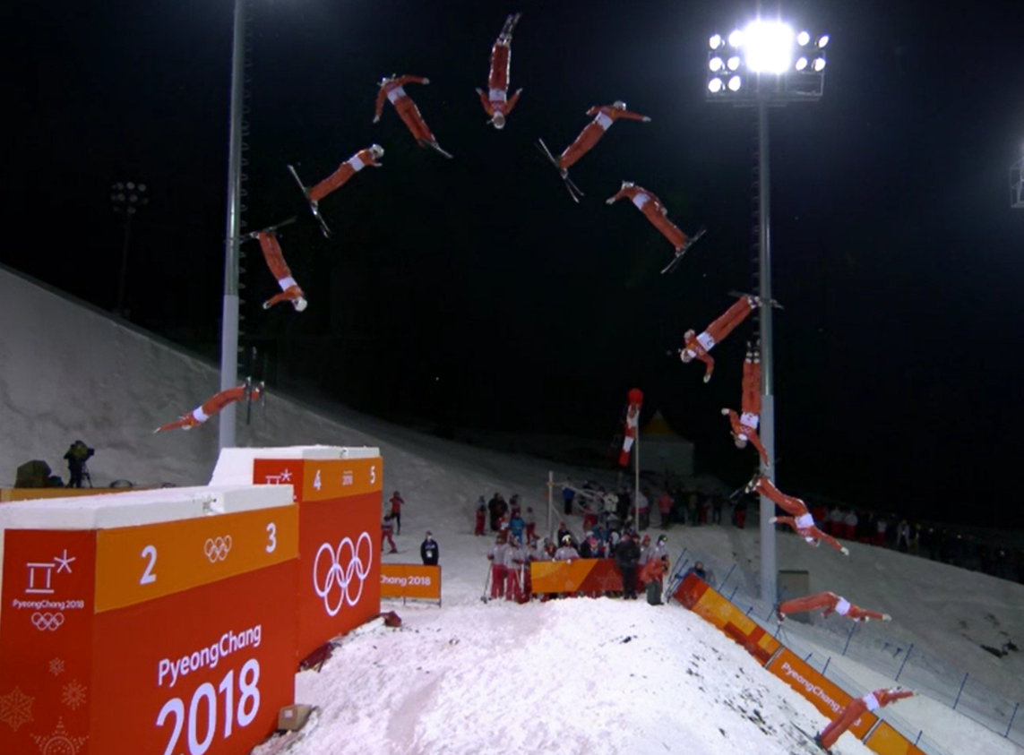

* 1. Find the initial speed of the ski-jumper: (2 Marks)
  2. Find the time to reach maximum height: (1 Mark)
  3. Find the frequency of the camera shutter (i.e. the number of times the shutter opens and closes): (2 Marks)
  4. Find the total time over which the image was taken: (2 Marks)
  5. Find the range of the jump: (2 Marks)

1. A soccer player kicks a soccer ball with a speed of 22.0 m s-1 at an angle to the horizontal of 31˚. The ball achieves a maximum height of 6.55 m, before hitting an unsuspecting stationary opposing player in the head. By *estimating* the height of the opposing player, calculate how far away he was standing from the kicker when the ball was kicked.

(5 Marks)





6.55 m

22.0 m/s

? m

31˚

1. A student tries to throw her ball over a tall fence. The ball is launched at an angle θ to the horizontal. The ball reaches its maximum height of 4.40 m above the ground, continues and then strikes the top of the fence at a horizontal distance of 5.20 m in front of her. The flight time from the launch position to striking the fence was 0.850 s.

Maximum height = 4.40 m

Range = 5.20 m

Student launches ball from 1.70 m above ground

θ

u

1. Calculate the initial velocity of the ball. Note that this is a vector quantity.

(5 Marks)

1. Calculate the height of the fence. If you could **not solve** for the initial velocity **u** then use a value of 9.50 m s-1 at 55.0° above the horizontal.

(4 Marks)

1. The kinetic energy of the ball after 0.450 seconds of flight was 19.14 J. Calculate the mass of the ball.

(4 Marks)

END OF TEST